**PART A**

**Experiment No. 01**

**A.1 AIM:**

Create Home using HTML and CSS

**A.2 Pre requisite:**

Basic Knowledge of HTML and CSS and HTML tags

**A.3 Outcome:**

After successful completion of this experiment students will be able to understand to concept of designing forms using CSS

**Problem1: create a home page and a simple website form as give below**

1. Create a Website Home page as given below

2.Use Non-Semantic Tags like <div> and <span> and Semantic Tags like <header>, <nav>, <main> and <footer> to create this page.

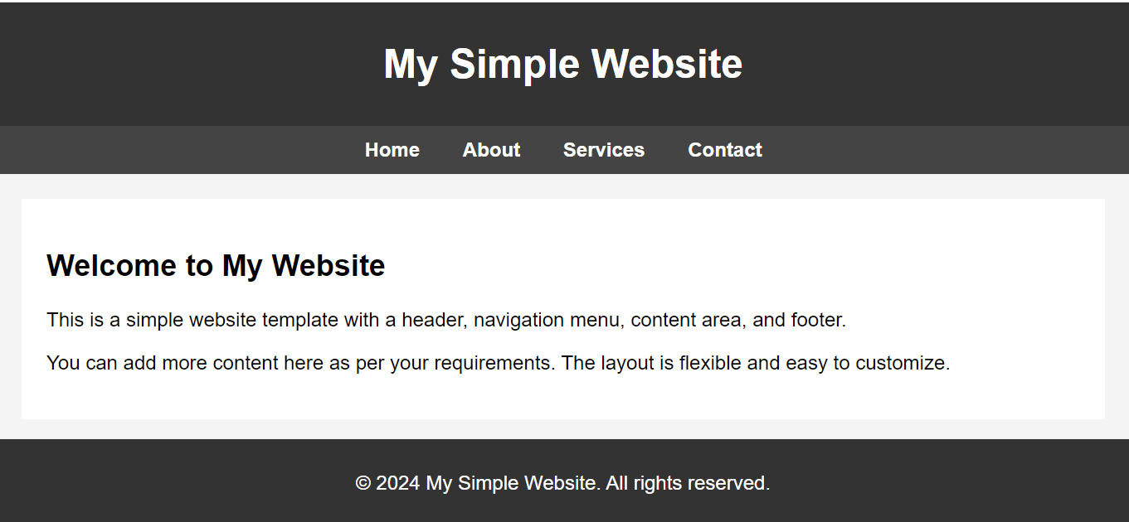

1. Create navigation links ("Home", "About", "Services", "Contact") to different sections of the page.
2. Create the main content with a subheading ("Welcome to My Website") and a brief description.
3. Create a copyright notice ("© 2024 My Simple Website. All rights reserved.").
4. Use style sheet with attributes given below

| **CSS Selector** | **Targeted Element** | **Description** | **Styles Applied** |
| --- | --- | --- | --- |
| body | Entire webpage | Applies global styles to the entire webpage. | * - Font family: Arial, sans-serif - Margin: 0 (removes default margin) - Padding: 0 (removes default padding) - Background color: #f4f4f4 (light gray) |
| header | Header section | Styles the header of the webpage. | * - Background color: #333 (dark gray) - Text color: #fff (white) - Padding: 10px 0 (10px top/bottom, 0px left/right) - Text alignment: center |
| nav | Navigation bar | Styles the navigation bar containing links. | * - Background color: #444 (slightly lighter dark gray) -Padding:10px - Text alignment: center |
| nav a | Navigation links | Styles individual links within the navigation bar. | * - Text color: #fff (white) - Margin: 0 15px (0px top/bottom, 15px left/right) - Text decoration: none (removes underline) - Font weight: bold |
| nav a:hover | Hover state of links | Changes the appearance of links when hovered over. | * - Text decoration: underline (adds underline when hovered) |
| main | Main content area | Styles the main content area of the webpage. | * - Padding: 20px - Background color: #fff (white) - Margin: 20px |
| footer | Footer section | Styles the footer, which is fixed at the bottom of the webpage. | * - Background color: #333 (dark gray) - Text color: #fff (white) - Text alignment: center - Padding: 10px 0 - Position: fixed - Bottom: 0 - Width: 100% |

Prepare the document. Save and close the file and name it as **EXP01_Roll no_Batch no.**

**PART B**

(PART B: TO BE COMPLETED BY STUDENTS)

(Students must submit the soft copy as per following segments within two hours of the practical. The soft copy must be uploaded on the Blackboard or emailed to the concerned lab in charge faculties at the end of the practical in case the there is no Black board access available)

|  |  |
| --- | --- |
| Roll No. : S020 | Name: Husain Chhil |
| Class : MBA.Tech DS | Batch : J1 |
| Date of Experiment : 29/08/2024 | Date/Time of Submission : 29/08/2024 |
| Grade : |  |

**B.1 Code:**

/* style.css */

body {

  font-family: Arial, sans-serif;

  margin: 0;

  padding: 0%;

  background-color: #f4f4f4;

}

header {

  background: #333;

  color: #fff;

  padding: 10px 0;

  text-align: center;

}

nav {

  background: #444;

  color: #fff;

  text-align: center;

  padding: 10px 0;

}

nav a {

  color: #fff;

  margin: 0 15px;

  text-decoration: none;

  font-weight: bold;

}

nav a*:hover* {

  text-decoration: underline;

}

main {

  padding: 20px;

  background-color: #fff;

  margin: 20px;

}

footer {

  background: #333;

  color: #fff;

  text-align: center;

  padding: 10px 0;

  position: fixed;

  bottom: 0;

  width: 100%;

}

<html>

    <link *rel*="stylesheet" *type*="text/css" *href*="style.css">

    <header>

        <h1>My Website</h1>

    </header>

    <nav>

        <a *href*="home.html">Home</a>

        <a *href*="about.html">About</a>

        <a *href*="contact.html">Contact</a>

        <a *href*="services.html">Services</a>

    </nav>

    <body>

        <main>

            <h2>Welcome to my website</h2>

            <p>This is my first website. I am learning web development.<br> This is a simple website with few pages.</p>

        </main>

        <footer>

            <p>&copy; 2024 My Website. All Rights Reserved</p>

        </footer>

    </body>

</html>

**B.2 Output**

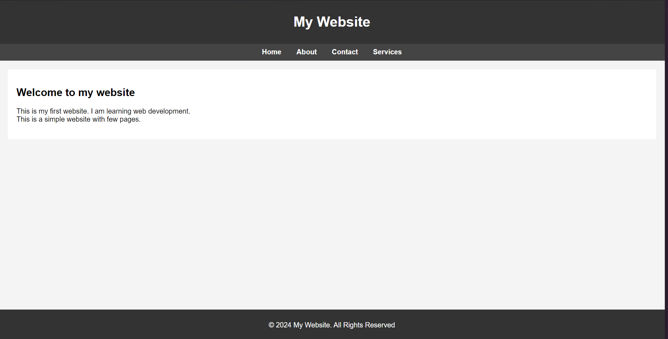

**B.3 Conclusion:**

*The above code is a simple HTML code for a website. It has a header, navigation bar, main content, and footer.*

**B.3 Observations and Learning:**

*The above code is a simple HTML code for a website. It has a header, navigation bar, main content, and footer. The header tag is used to define the header of a document or a section. The nav tag is used to define a set of navigation links.*

**B.4 Question of Curiosity**

Q1. Types of CSS:

1. Inline CSS: Applied directly within an HTML element using the `style` attribute.
2. Internal CSS: Defined within a `<style>` tag in the HTML `<head>`.
3. External CSS: Linked via an external stylesheet.

Q2. HTML Semantic Tags:

Semantic tags clearly describe their meaning in a human- and machine-readable way. Examples include:

- `<header>`: Defines a header section.

- `<article>`: Defines independent content.

- `<footer>`: Defines a footer section.

Q3. Types of Selectors:

1. Element Selector: Targets all instances of a given HTML tag.
2. Class Selector: Targets elements with a specific class.
3. ID Selector: Targets an element with a specific ID.

Each type allows for targeting elements based on different criteria, providing flexibility in styling.